Rezoning the Kulaluk Lease – from Special Purpose Lease to Light Industry Sprawl.
The greatest land grab since the gold rush.
On March 7th, 2014, the Minister for Lands Planning and Environment, Peter Chandler, approved the rezoning of part of Lot 5182, Town of Darwin and part Lot 8630, town of Nightcliff on Dick Ward Drive directly opposite the T junction with Totem Road. The rezoning will be advertised in the Government Gazette on March 26, 2014.

The above decision was signed by the Minister on the same day that opponents of the subdivision of land between Fitzer Drive and Totem Road were making oral submissions to the Development Consent Authority at the Novotel Antrium Hotel on The Esplanade. I am reliably informed that after the March 7th hearing, the DCA rejected the application to subdivide land rezoned by Minister Gerry McCarthy on 6 June, 2011. In both of the above cases the land in question is part of the Kulaluk lease of 301 hectares granted to Aboriginal people in 1979. The arguments against extending the Coconut Grove industrial estate in a sprawl along Dick ward Drive are the same in both cases.

Submissions against the Totem Road rezoning approved by Mr Chandler on March7th, were made to the Senior Planner, Strategic Lands Planning, Department of Planning and Infrastructure on 21 June, 2013. It was the second time that this application to rezone had been advertised. Apparently the Minister has discounted our objections, including a submission by the traditional owners represented by the Larrakia Nation Aboriginal Corporation.

If the Totem Road development goes ahead on land rezoned by Peter Chandler on March 7th, the area at the end of Totem Road will be levelled of vegetation and filled, to prepare for an industrial estate similar to that existing in the nearby Coconut Grove light industry area. There will be a narrow laneway between sheds providing access to the lease. It is difficult to see how this alienation of a conservation zone (CN) could benefit the Darwin Aboriginal community.

As one who has been involved in setting aside the 301 hectare Kulaluk lease since 1971, I make the following objections:

- As Planit’s rezoning proposal suggests, there are very few parts of the Kulaluk lease suitable for development. This restriction also applies to alternative plans that include an interpretative centre, parking, staff facilities and similar sympathetically designed infrastructure needed to facilitate community and public use of the lease. The proposed light industry rezoning would severely inhibit plans for community developments on the Kulaluk lease by continuing the trend of ‘picking the eyes out’ of the lease.

- Dickward Drive offers an opportunity for a unique entrance to Darwin, rather than a highway lined by car yards and light industry. The proposed rezoning would put severely limit that opportunity.

- Ms Krimhilde Henderson’s Land Use Field Study of the Kulaluk Area commissioned by the Aboriginal Sacred Sites Protection Authority in 1983 documents the many ways that Aboriginal people in Darwin use the land and mangroves on the Kulaluk lease (Lot 5182 Town of Darwin and part Lot 8630, town of Nightcliff). As a result of her research, Ms Henderson sketched a diagram showing access paths used by Aboriginal people and others, in particular the track from Totem Road. Indeed this entrance to the lease is the only remaining all-year-round easy access now that many of these pathways have been blocked by development. To allow light industry development along Dickward Drive at the Totem Road entrance would ‘strangle the lease’ by further restricting access by Aboriginal people and others to so-called ‘core areas’ that are environmentally significant, such as the beach and monsoon forest.

- According to the proposal map, the entrance into the lease from Totem Road would be via a laneway between industrial sheds. Instead of a unique bushland entrance, the blast remaining all-season entrance to the lease would be hidden behind industrial sheds – an opportunity lost forever.

- Contradictory to the developers’ application, the proposed rezoning area contains a healthy stand of native vegetation as well as two large trees beside the track that have heritage value. These trees were planted by Kulaluk residents during the land rights struggle in the 1970s (see Google aerial photo attached).

- My 2008 report, Recommendations for a Kulaluk Wilderness, Heritage and Education Park details a plan for the use of the Kulaluk lease in accordance with the original intentions. The report argues that the benefits of the social, religious, historical and cultural value of the lease for Aboriginal people and the wider community far outweigh any rent from industrial development. For example, grants are available for land-management and educational programs that would employ many Aboriginal people.

- Documents submitted by me previously as evidence to the Senior Planner clearly prove that the intentions for creating the Kulaluk lease in negotiations from 1973 to 1979 were: (a) as compensation for the revoking of the old Bagot Aboriginal Reserve which extended from Totem Road to Ludmilla Creek; (b) a goodwill recognition of the Larrakia tribe’s prior occupation; (c) preservation of urban bushland and foreshores of heritage, cultural and ecological importance to Aboriginal people and others.

- My essay, The Carve Up of Aboriginal Land in Darwin documents how the leaseholders, the Gwalwa Daraniki Association, assisted by their lawyer, Michael Chin, have amended their constitution to limit membership to a ‘minimum of five’ in the interests of the small family group who live in the Kulaluk village in Nightcliff and to the detriment of others who have an interest in the Kulaluk land. My essay, Kulaluk and Land Rights, also documents how the current leaseholders have mismanaged the land leased to them for community purposes. In addition, my 1994 book, Bunji: a story of the Gwalwa Daraniki Movement, documents previous development proposals that suggest the present clique of leaseholders are not concerned by the wider community rights and interests in the land or the environmental, historical and cultural reasons for setting aside the land, except to use the lease for financial gain to the exclusion of others.

- The Kulaluk Lease Area Land Development Study by Holingsworth Consultants in 1985 established a continuing and self-fulfilling trend to view the Kulaluk lease as unused and unoccupied by indigenous people. The report also noted that: ‘Concern was expressed by an officer of the Department of Lands that if this development was to proceed [on the Kulaluk lease], then the Department could expect to receive applications for commercial development from other Aboriginal communities on other lands leased for community or living purposes throughout the Territory.’

- Documents submitted record the burial of over 200 Aboriginal people throughout the lease, and not just confined to the burial ground whose pukamini poles gave the name to Totem Road. According to Henderson’s map (attached) the proposed industrial estate overlaps a known burial ground and is close to a well-recorded Aboriginal cemetery.

- The report, Management Objectives for East Point Reserve, previously submitted, describes the Kulaluk lease as an integral part of the East Point ecology, and suggests that the two areas should be managed conjointly. Further alienation of the Kulaluk lease should not be considered until the above report is considered.

Since the Arafura Harbour and Planit P/L proposals for developments on the Kulaluk lease many concerned citizens have spent the best part of 4 years working to preserve the lease from developments not in keeping with the original intention and purposes of what was originally granted as a ‘needs claim’ for Larrakia and associated Aboriginal people. As in the case of Arafura Harbour, much heart-ache and time-consuming work could be avoided by some political courage to ensure that the Kulaluk lease will be used for all time in accordance with its intentions under a responsibly appointed Lands Trust. This would allow future direction planning and the commencement of genuine long-term employment schemes.

The founders could never envisage the area they fought to preserve being used as an industrial estate. For example they proudly ensured an additional provision in the original lease ‘that no tree be destroyed’.

In 1973 the final report of the Aboriginal Land Rights Commissioner, Judge A E Woodward, documented in detail the alienation of Aboriginal land in Darwin as a precautionary tale against the this process, however well-intentioned, being repeated in the future. I submit that the light industry estate will be of no benefit to the majority of Aboriginal people with an interest in the Kulaluk land, and will accelerate the process of alienation of land set aside for Aboriginal use in Darwin.

I attach two documents that describe the location of two sacred sites in the areas prosed for development.
• A letter and map from David Ritchie of the Aboriginal Sacred Sites Authority (as it was in 1982) written to the Gwalwa Daraniki Association describing two sacred sites on the lease that are within the present proposed rezoning of Lot 5182.
• A map from Krimhilde Henderson’s 1983 report, Land Use Field Study of the Kulaluk Area. (This report has also previously been submitted as evidence to the Senior Planner.) Ms Henderson was commissioned by the Aboriginal Sacred Sites Authority; therefore I believe her map is based on, or almost identical to, the map referred to by David Ritchie in his letter.

The letter from David Ritchie describing the sites remarks that Dr Ritchie does not feel it would be necessary to register all the sacred sites on the Kulaluk lease because the land was now safely preserved as ‘Aboriginal land’. In other words, David Ritchie expressed the sentiments of all involved in the Kulaluk campaign of the 1970s that the land was for Aboriginal people and would be administered for Aboriginal people, respecting their culture, history and sites. The letter supports my contention that it was never intended that the land could be alienated for the financial benefit of a few.

It is important to note that the land is not held under the Land Rights Act or the Native Title Act. If it were so, the safeguards for the traditional owners would be greater, as revealed in the following sections of the Land Rights Act 1976:

S.19A(2) A Land Council must not give a direction under subsection (1) for the grant of a lease unless it is satisfied that:
(a) the traditional owners (if any) of the land understand the nature and purpose of the proposed lease and, as a group, consent to it; and
(b) any Aboriginal community or group that may be affected by the proposed lease has been consulted and has had adequate opportunity to express its view to the Land Council; and
(c) the terms and conditions of the proposed lease (except those relating to matters covered by this section) are reasonable.

II trust that for the above reasons, the proposed rezoning will not be approved. I dedicate this submission to the late Brigid Oulsnam who prepared the previous objection to this application for the Proposal to rezone part of Lot 5182, Town of Darwin and part Lot 8630, town of Nightcliff on Dick Ward Drive.

Dr William B Day
Consulting Anthropologist

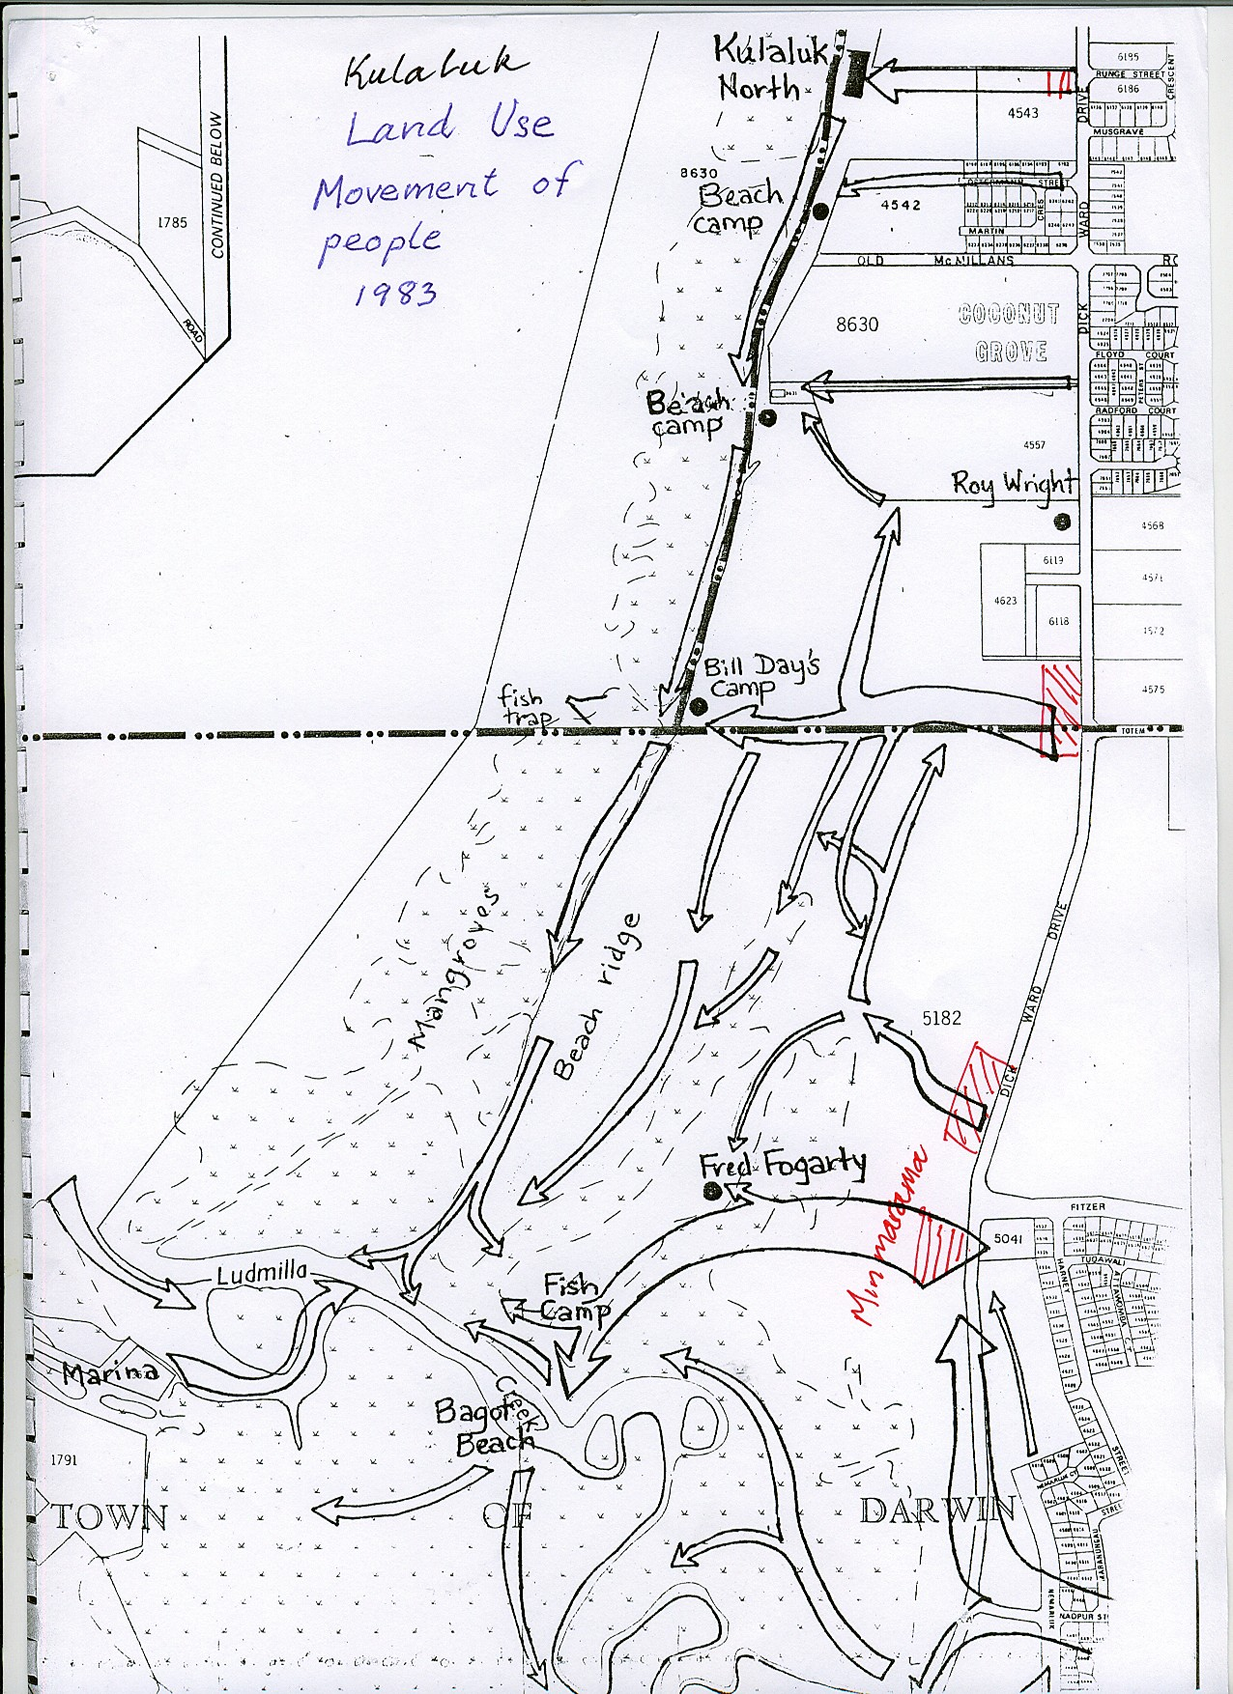
Above: Map of people movements on the Kulaluk lease over three months made by Krimhilde Henderson in her Kulaluk Land Use Field Study 1983. All these pathways are being hindered by ad hoc development and rezoning.
Kulaluk: Some Areas of Significance, Burial Grounds, Ceremony Grounds
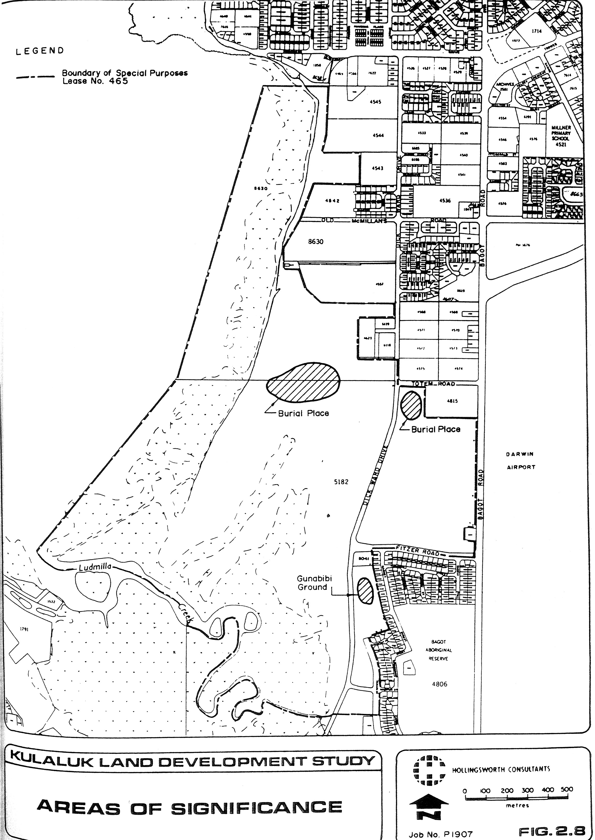
Above: Map from Hollingsworth Consultants (1985) Kulaluk Lease Area Land Development Study.
Based on previous map by Aboriginal Sacred Sites Protection Authority, 1983.
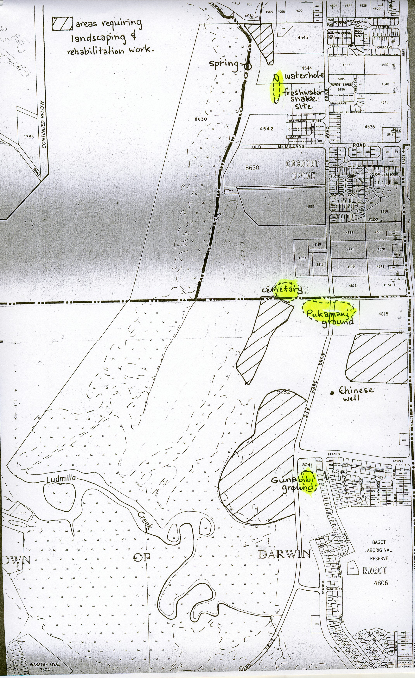
Above: Map from Henderson, Krimhilde (1983) Land Use Field Study of the Kulaluk Area, Aboriginal Sacred Sites Protection Authority.

